# Drive Tru – Pre-Owned Car Marketplace

# Business Requirements Document

## 1. Executive Summary

Drive Tru is a digital platform for buying and selling certified pre-owned Suzuki and Citroen vehicles in the UAE. This document outlines the business requirements for the web application accompanied by a functional design prototype

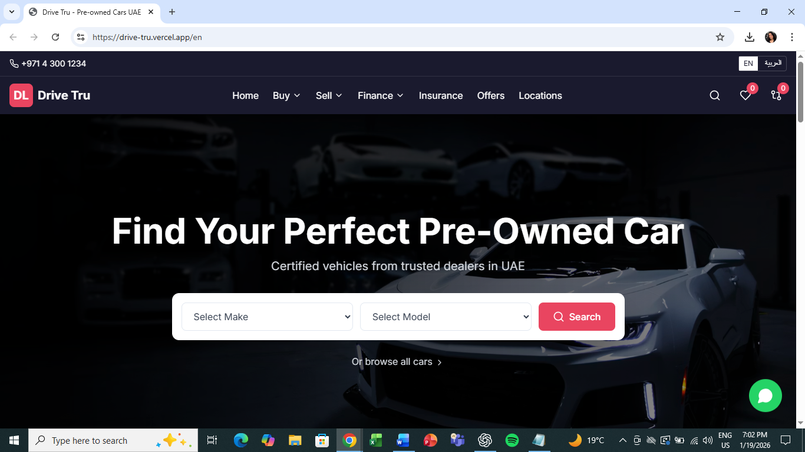

### Project Objectives

**Create a seamless car buying experience for UAE customers**The platform will simplify the end-to-end customer journey by enabling easy discovery, comparison, and enquiry of pre-owned vehicles through an intuitive and responsive web interface.  
  
**Enable instant online valuations for sellers**Drive Tru will allow sellers to receive quick and indicative valuations for their vehicles using structured inputs, reducing dependency on manual assessments and accelerating lead generation.  
  
**Integrate with existing ARTC systems (KeyLoop DMS, SAP)**  
The platform will integrate with ARTC’s core enterprise systems to ensure accurate inventory data, financial alignment and minimal operational overhead through automated data exchange.  
  
**Publish inventory to third-party marketplaces (Dubizzle, YallaMotors)**  
Approved vehicle listings will be published to external automotive marketplaces to increase visibility, drive demand and maximize lead acquisition.  
  
**Provide bilingual support (English & Arabic with RTL)**  
The platform will support both English and Arabic languages with proper RTL handling to cater to the diverse user base in the UAE and ensure accessibility for all customers.

### Prototype Reference

A working design prototype accompanies this document, demonstrating: - All user flows and page layouts - Sample data and interactions - Admin CMS workflow mockups

## 2. Scope Overview

### In Scope

**Car browsing & search**  
Users will be able to browse the full inventory of available vehicles using structured filters and search capabilities.

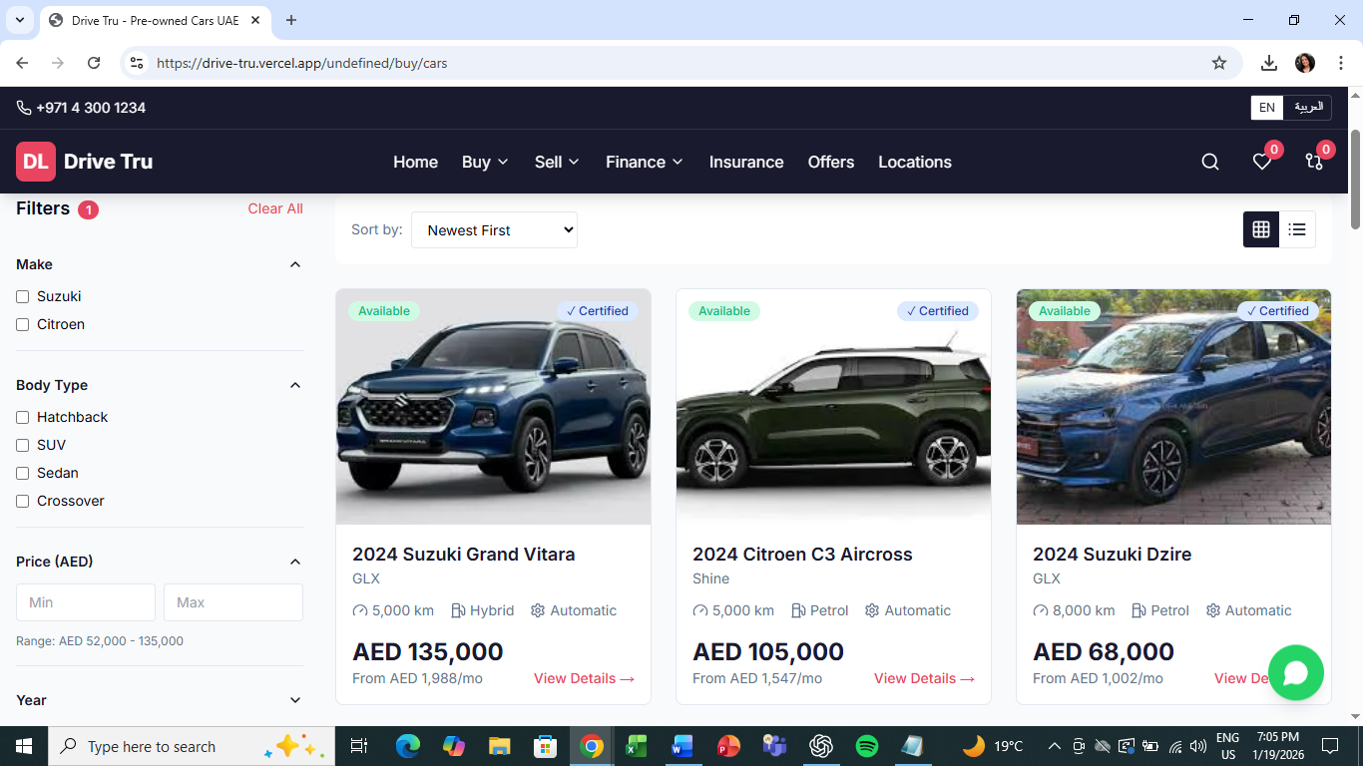  
  
**Car detail pages**  
Each vehicle will have a detailed page displaying specifications, pricing, images and enquiry options.

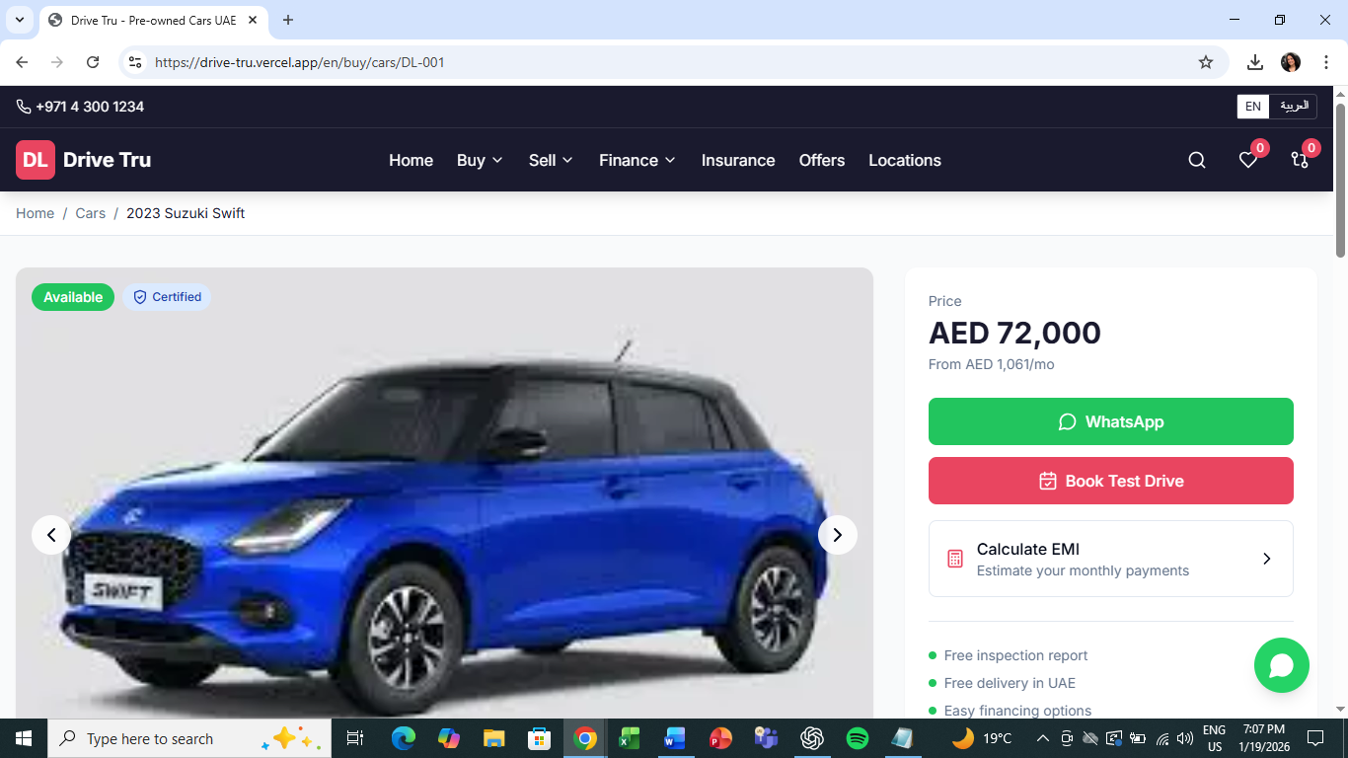

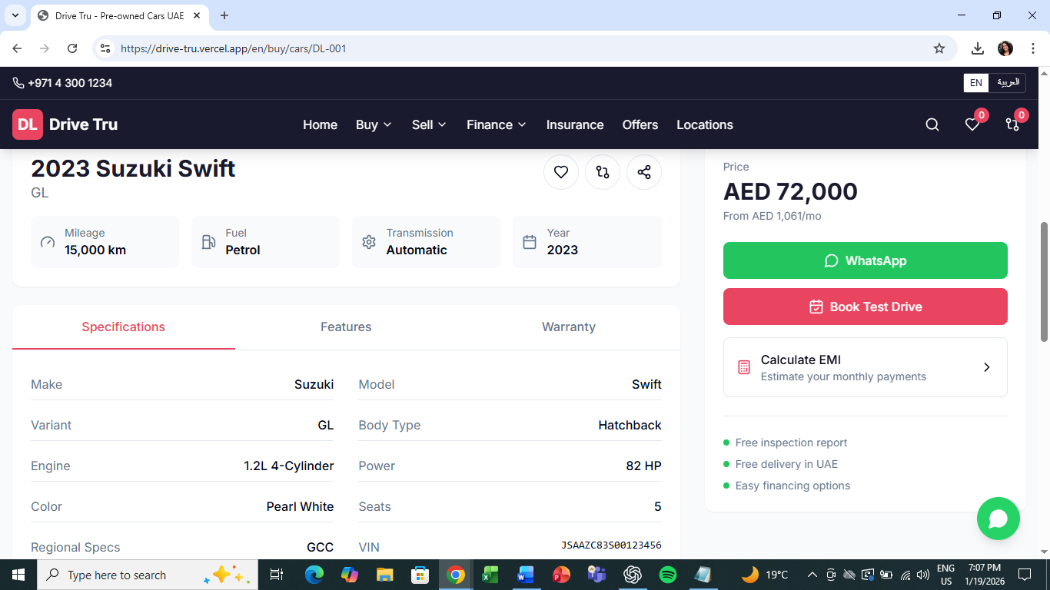

**Compare & favorites**  
Customers will be able to shortlist vehicles for comparison and save favorites for easy reference

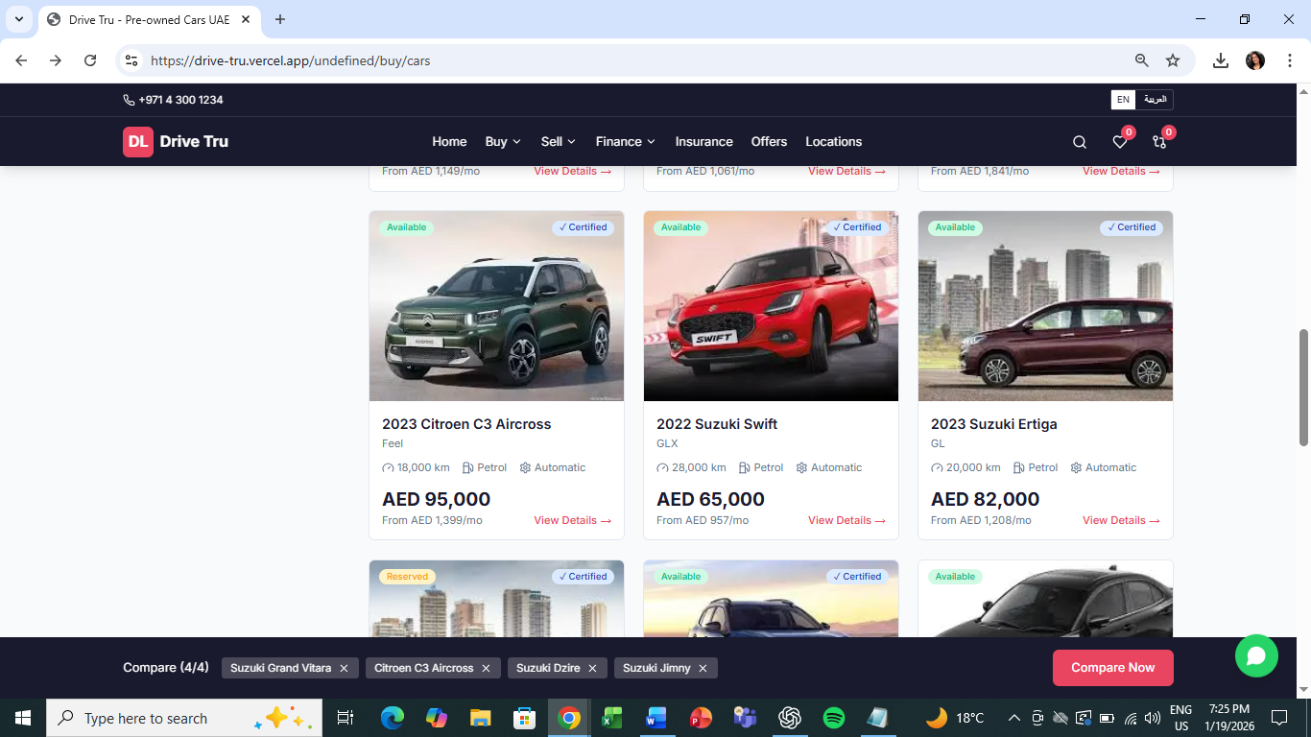

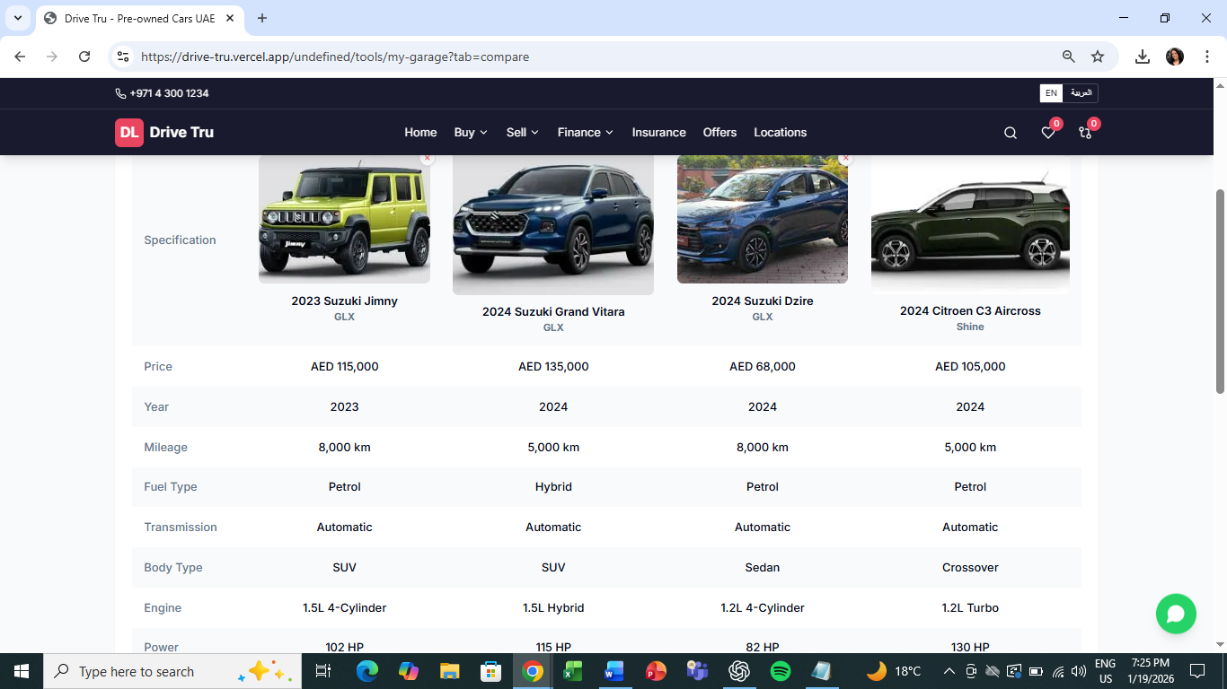

**EMI calculator**The platform will provide an indicative EMI calculator to support informed purchase decisions.

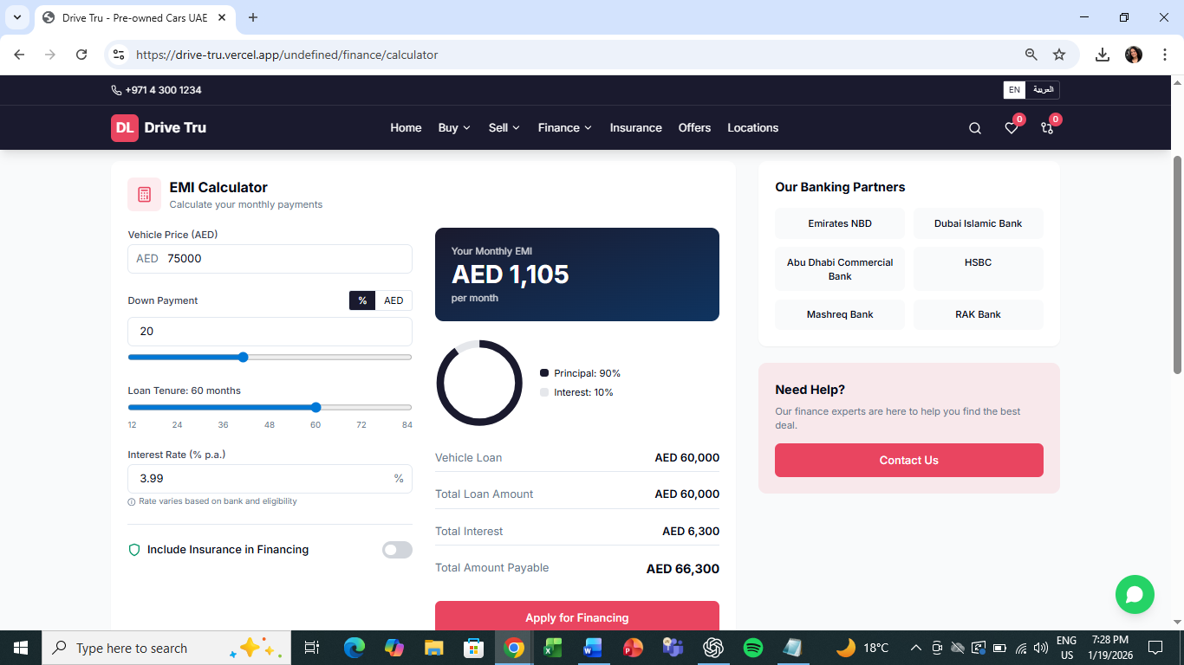

**Sell/Trade-in valuation flow**  
Users can submit vehicle details to receive instant valuation ranges for selling or trading in their cars.

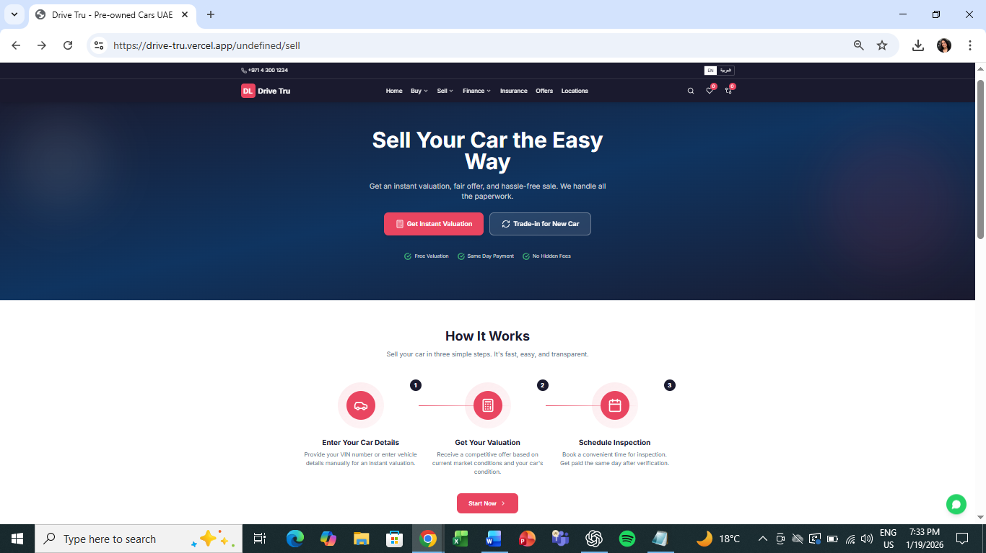

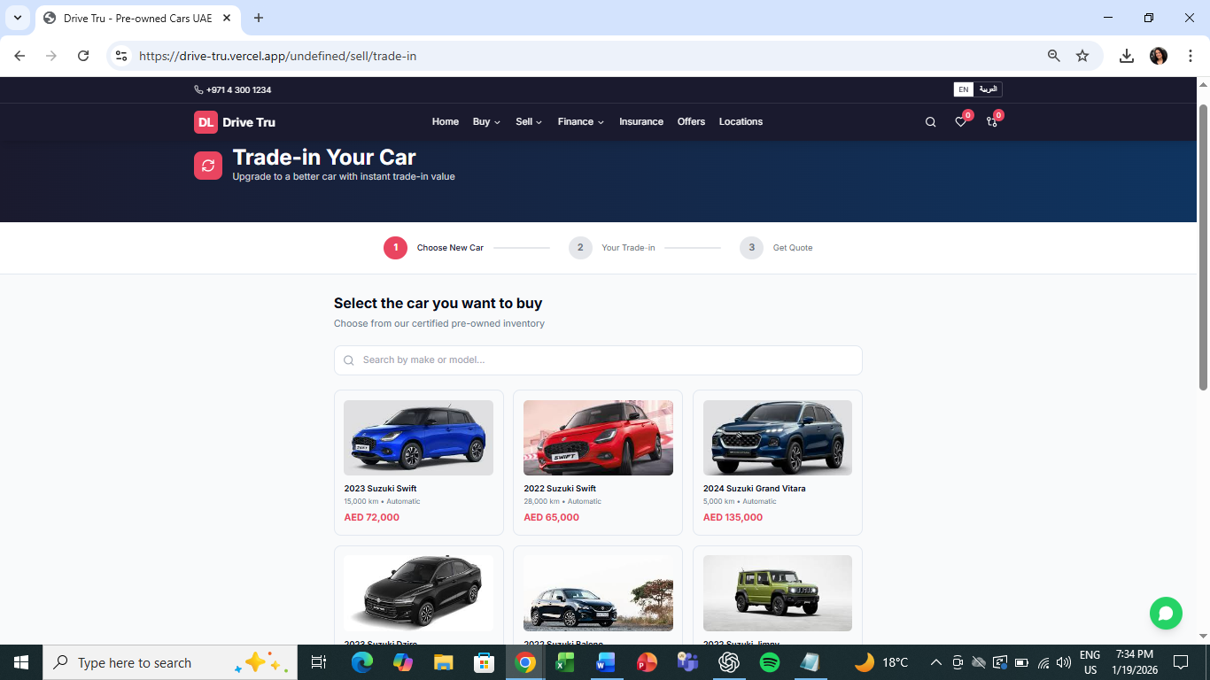

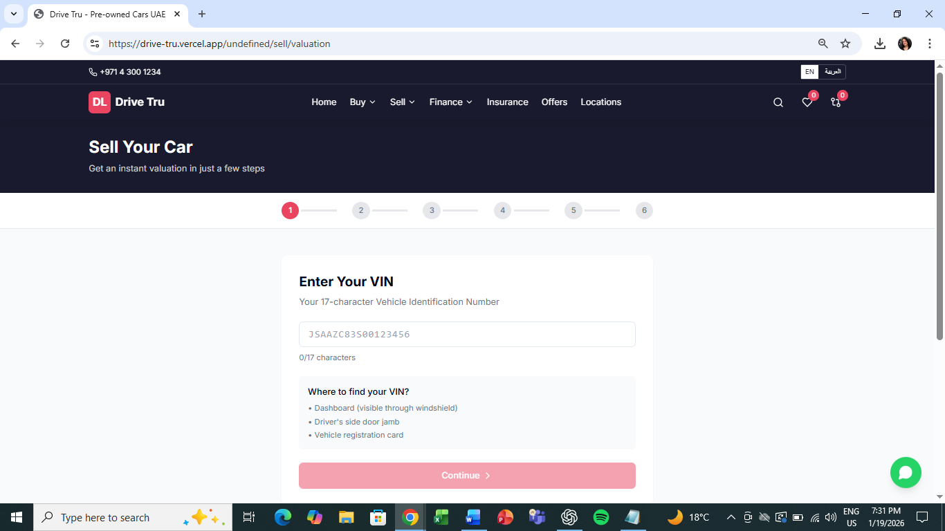   
  
**Finance eligibility form**  
Customers can submit finance-related details to check indicative eligibility and capture leads.

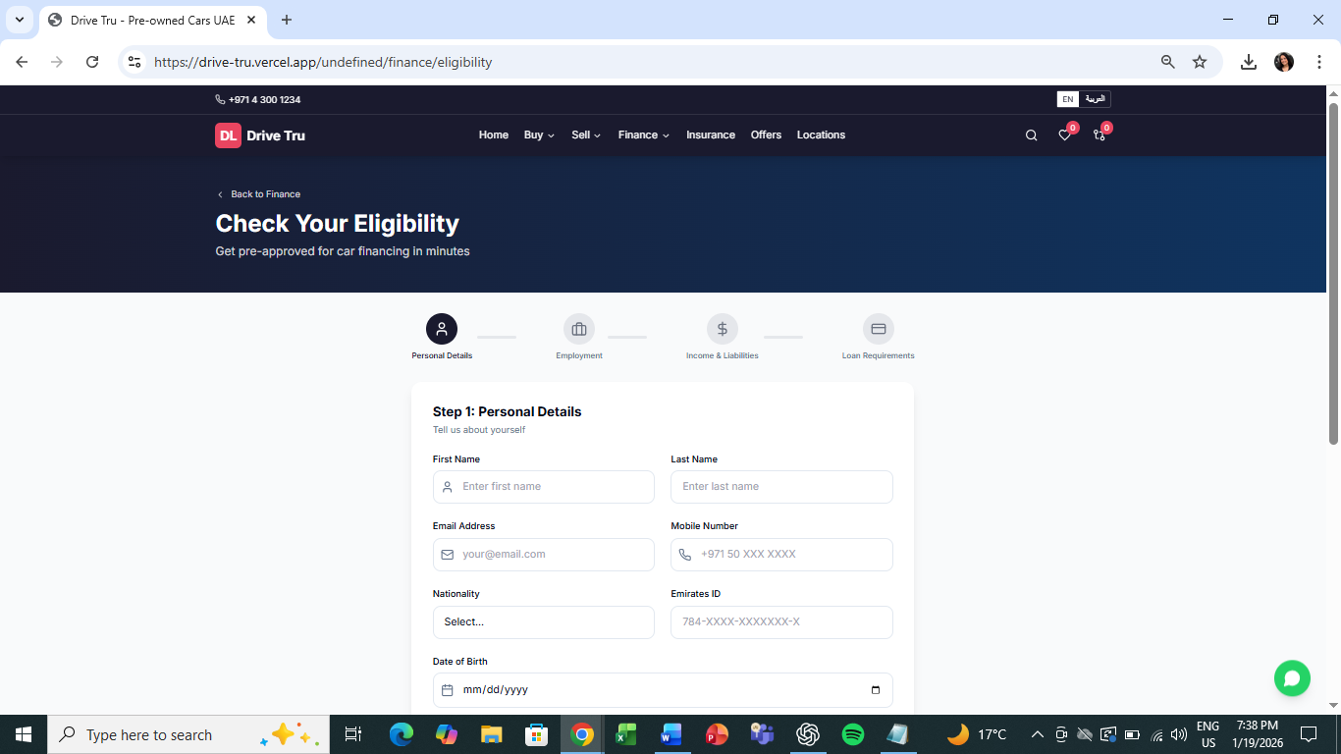

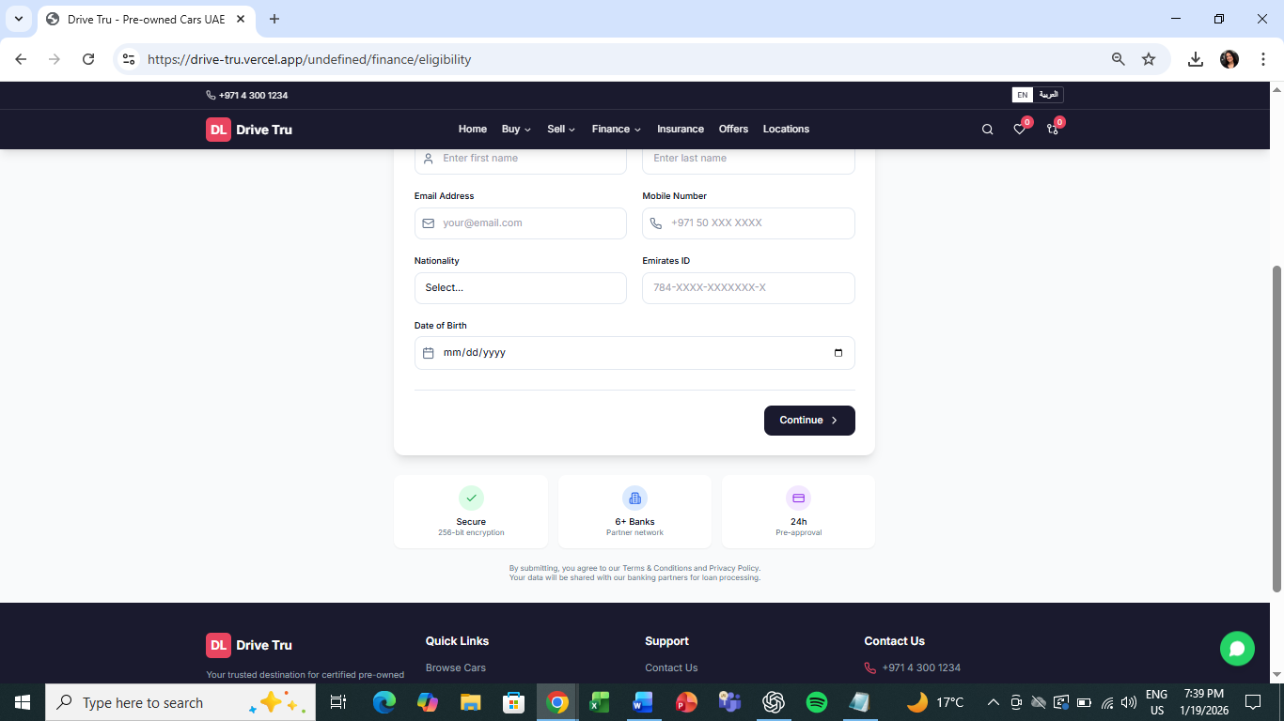  
  
**Admin CMS for approvals**  
Internal teams can review, approve and manage vehicle listings before publication.  
  
**multi-platform publishing**  
Approved inventory can be published across multiple digital marketplaces.  
  
**EN/AR bilingual support**  
The platform will support English and Arabic with appropriate RTL handling.

### Out of Scope (Phase 1)

**User account system**  
Persistent user accounts and login-based personalization are excluded from Phase 1.  
  
**Real payment processing**  
End-to-end online payments are not part of the initial release.  
  
**AI-powered recommendations**  
Advanced personalization and recommendation engines are excluded.  
  
**Mobile native apps**  
The platform will be web-based only in Phase 1.  
  
**Real-time bidding**  
Auction-style bidding mechanisms are not included.

**Dealer Portal**Dealer-facing inventory or lead management portals are excluded from Phase 1.

## 3. User Personas

### 3.1 Buyer

**Goal:** Find and purchase a certified pre-owned vehicle

**Key Journeys:** 1. Browse → Filter → View Details → Compare → Contact/Finance 2. Calculate EMI → Check eligibility → Apply for financing 3. Get insurance quote → Select coverage

### 3.2 Seller

**Goal**: Sell or trade-in their existing vehicle

**Key Journeys**: 1. Enter VIN → Confirm details → Upload photos → Mark damage → Get valuation 2. Select car to buy → Enter trade-in details → View combined quote

### 3.3 Quality Team (Admin)

**Goal:** Review, approve and publish inventory

**Key Journeys**: 1. Review pending listings → Approve/Reject → Publish to platforms 2. Manage inventory status → Sync with marketplaces 3. Monitor integration health → Configure settings

## 4. Functional Requirements

#### F-001: Car Browsing & Search

| **ID** | **Requirement** | **Priority** |
| --- | --- | --- |
| F-001.1 | Display car inventory with grid/list view toggle | Must |
| F-001.2 | Filter by: Make, Model, Year, Price, Mileage, Body Type, Fuel, Transmission, Specs | Must |
| F-001.3 | Sort by: Price, Year, Mileage, Recently Added | Must |
| F-001.4 | Search by keyword (make/model) | Must |
| F-001.5 | Display status badges (Available, Reserved, Sold) | Must |
| F-001.6 | Pagination with results count | Must |

#### 

#### F-002: Car Detail Page

| **ID** | **Requirement** | **Priority** |
| --- | --- | --- |
| F-002.1 | Image gallery with thumbnails (multimedia support) | Must |
| F-002.2 | Full vehicle specifications display | Must |
| F-002.3 | Price display in AED | Must |
| F-002.4 | EMI estimate with link to calculator | Must |
| F-002.5 | WhatsApp inquiry button | Must |
| F-002.6 | Book test drive form | Must |
| F-002.7 | Add to compare (max 4 vehicles) | Must |
| F-002.8 | Add to favorites | Must |
| F-002.9 | Similar vehicles section | Should |

#### F-003: Compare Feature

| **ID** | **Requirement** | **Priority** |
| --- | --- | --- |
| F-003.1 | Add up to 4 cars for comparison | Must |
| F-003.2 | Side-by-side specification table | Must |
| F-003.3 | Sticky compare bar showing selected vehicles | Must |
| F-003.4 | Remove individual vehicles from comparison | Must |

#### F-004: Favorites/My Garage

| **ID** | **Requirement** | **Priority** |
| --- | --- | --- |
| F-004.1 | Save vehicles to favorites (no login required) | Must |
| F-004.2 | View saved favorites list | Must |
| F-004.3 | Favorites count badge in header | Must |
| F-004.4 | Combined view with compare list | Should |

#### 

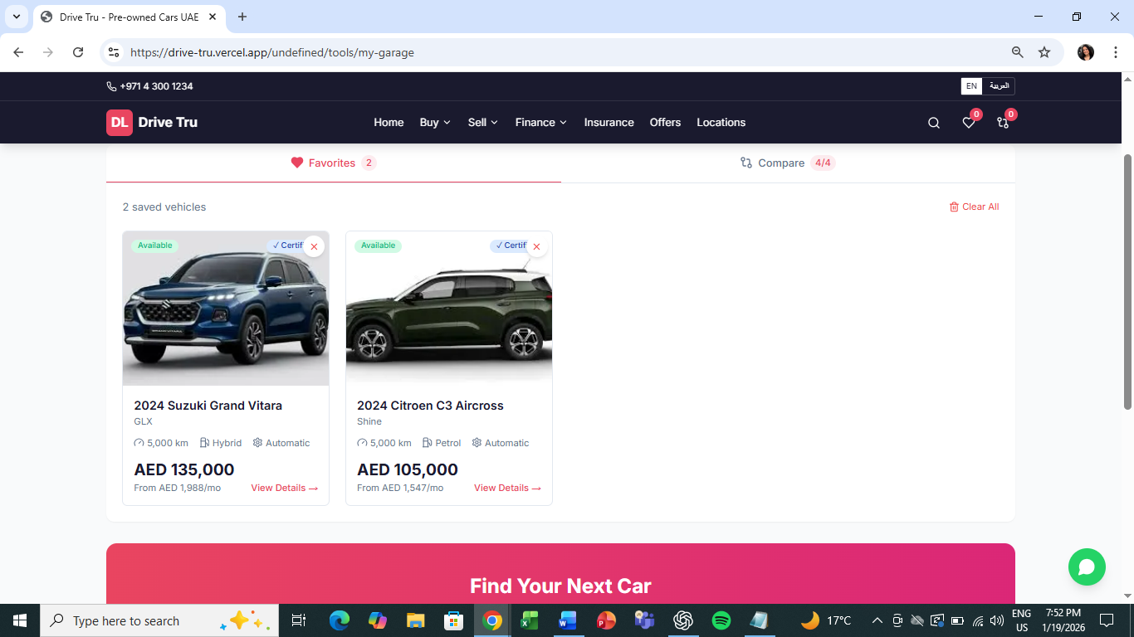

#### F-005: EMI Calculator

| **ID** | **Requirement** | **Priority** |
| --- | --- | --- |
| F-005.1 | Vehicle price input (pre-filled or manual) | Must |
| F-005.2 | Down payment input (amount or percentage) | Must |
| F-005.3 | Loan tenure slider (12-84 months) | Must |
| F-005.4 | Adjustable interest rate | Should |
| F-005.5 | Real-time EMI calculation | Must |
| F-005.6 | Display total interest and total amount | Must |

#### F-006: Finance Eligibility

| **ID** | **Requirement** | **Priority** |
| --- | --- | --- |
| F-006.1 | Multi-step eligibility form | Must |
| F-006.2 | Capture: Personal, Employment, Income, Loan details | Must |
| F-006.3 | Per-step validation | Must |
| F-006.4 | Pre-approval result with reference number | Must |
| F-006.5 | Lead capture for CRM integration | Must |

#### F-007: Insurance Quote

| **ID** | **Requirement** | **Priority** |
| --- | --- | --- |
| F-007.1 | Vehicle details input | Must |
| F-007.2 | Coverage type selection (Comprehensive, Third Party, etc.) | Must |
| F-007.3 | Optional add-ons selection | Should |
| F-007.4 | Quote calculation and display | Must |
| F-007.5 | Coverage comparison table | Should |

#### 

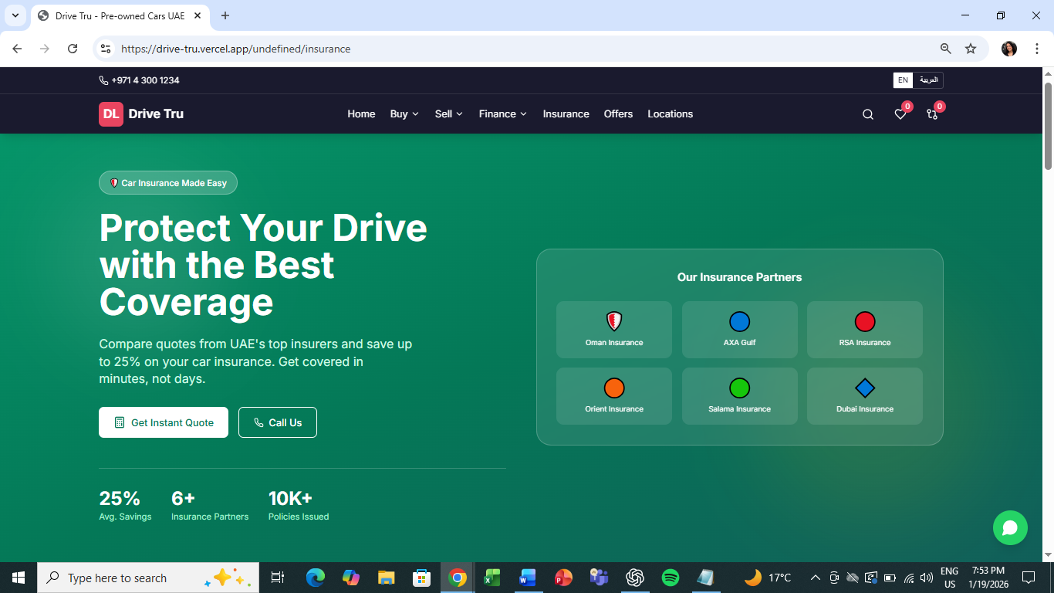

#### F-008: Sell My Car – Valuation

| **ID** | **Requirement** | **Priority** |
| --- | --- | --- |
| F-008.1 | VIN input with decoder | Must |
| F-008.2 | Vehicle details confirmation | Must |
| F-008.3 | Mileage and condition input | Must |
| F-008.4 | Photo upload interface | Must |
| F-008.5 | Damage marking stencil (vehicle diagram) | Should |
| F-008.6 | Instant valuation result (price range) | Must |
| F-008.7 | Lead capture for follow-up | Must |

#### F-009: Trade-In

| **ID** | **Requirement** | **Priority** |
| --- | --- | --- |
| F-009.1 | Select vehicle to purchase from inventory | Must |
| F-009.2 | Enter trade-in vehicle details | Must |
| F-009.3 | Display combined quote | Must |

### 

### 4.2 Admin CMS (Quality Team)

#### F-010: Dashboard

| **ID** | **Requirement** | **Priority** |
| --- | --- | --- |
| F-010.1 | Overview statistics (pending, approved, published) | Must |
| F-010.2 | Recent activity feed | Must |
| F-010.3 | Pending alerts and warnings | Should |
| F-010.4 | Quick action shortcuts | Should |

#### 

#### F-011: Approval Workflow

| **ID** | **Requirement** | **Priority** |
| --- | --- | --- |
| F-011.1 | Pending approvals queue | Must |
| F-011.2 | Filter by status (Pending, Approved, Rejected) | Must |
| F-011.3 | View listing details with images | Must |
| F-011.4 | Approve action with status update | Must |
| F-011.5 | Reject with reason selection and notes | Must |
| F-011.6 | Bulk approve/reject capability | Should |

#### 

#### F-012: Marketplace Publishing

| **ID** | **Requirement** | **Priority** |
| --- | --- | --- |
| F-012.1 | Platform overview (Website, Dubizzle, YallaMotors) | Must |
| F-012.2 | Select vehicles for publishing | Must |
| F-012.3 | Publish to multiple platforms | Must |
| F-012.4 | Publication status indicators | Must |
| F-012.5 | Sync status with timestamps | Should |

#### 

#### F-013: Inventory Management

| **ID** | **Requirement** | **Priority** |
| --- | --- | --- |
| F-013.1 | Full inventory list view | Must |
| F-013.2 | Filter and sort capabilities | Must |
| F-013.3 | Status management (Available, Reserved, Sold) | Must |
| F-013.4 | View/Edit actions | Should |

### 4.3 Platform Features

#### F-014: Multi-Language Support

| **ID** | **Requirement** | **Priority** |
| --- | --- | --- |
| F-014.1 | Language toggle (English/Arabic) | Must |
| F-014.2 | RTL layout for Arabic | Must |
| F-014.3 | URL-based locale (/en, /ar) | Must |
| F-014.4 | Translated navigation and key content | Must |

#### F-015: Responsive Design

| **ID** | **Requirement** | **Priority** |
| --- | --- | --- |
| F-015.1 | Desktop optimized layout | Must |
| F-015.2 | Mobile responsive design | Must |
| F-015.3 | Touch-friendly interactions | Must |

## 5. Integration Requirements

| **Integration** | **Purpose** | **Direction** | **Priority** |
| --- | --- | --- | --- |
| KeyLoop DMS | Vehicle inventory sync | Inbound | Must |
| AI Studio(please provide the correct app) | vehicle images+video received from the 3rd party | Inbound | Should |
| Pixel Ride | Enhanced vehicle photos | Inbound | Should |
| AlgoDriven | Automated valuations | Outbound/Inbound | Must |
| Zoho CRM | Lead management | Outbound | Must |
| Dubizzle API | Marketplace publishing | Outbound | Must |
| YallaMotors API | Marketplace publishing | Outbound | Must |
| SAP | Financial/backend sync (please SAP module + use cases in detail) | Bidirectional | Should |
| WhatsApp Business | Customer communication | Outbound | Must |
| Google Maps | Store locator | Inbound | Must |

## 6. Content Requirements

### 6.1 Static Pages

* Home page with hero, featured cars, USPs
* About Drive Tru
* Finance landing with bank partners
* Insurance information
* Offers/Promotions
* Store locations with maps
* Contact page with form
* Terms & Conditions
* Privacy Policy

**Offers/Promotions**

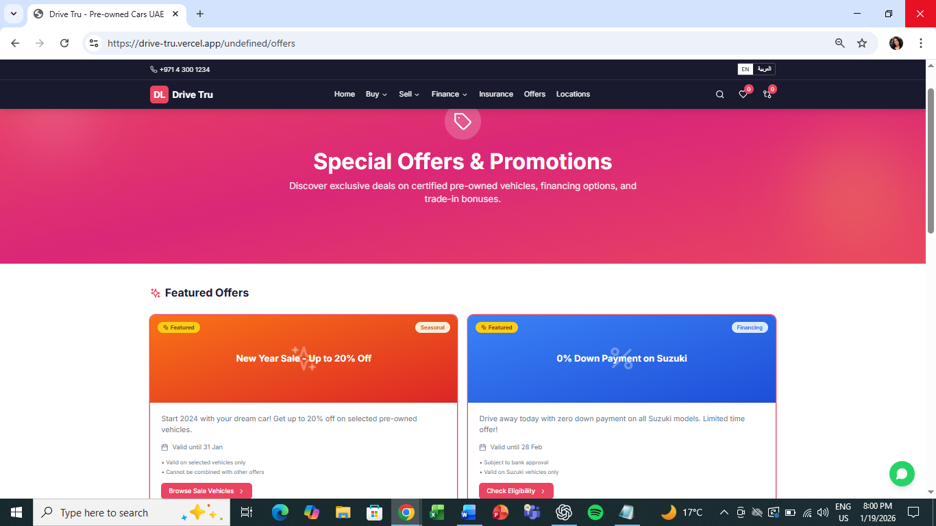

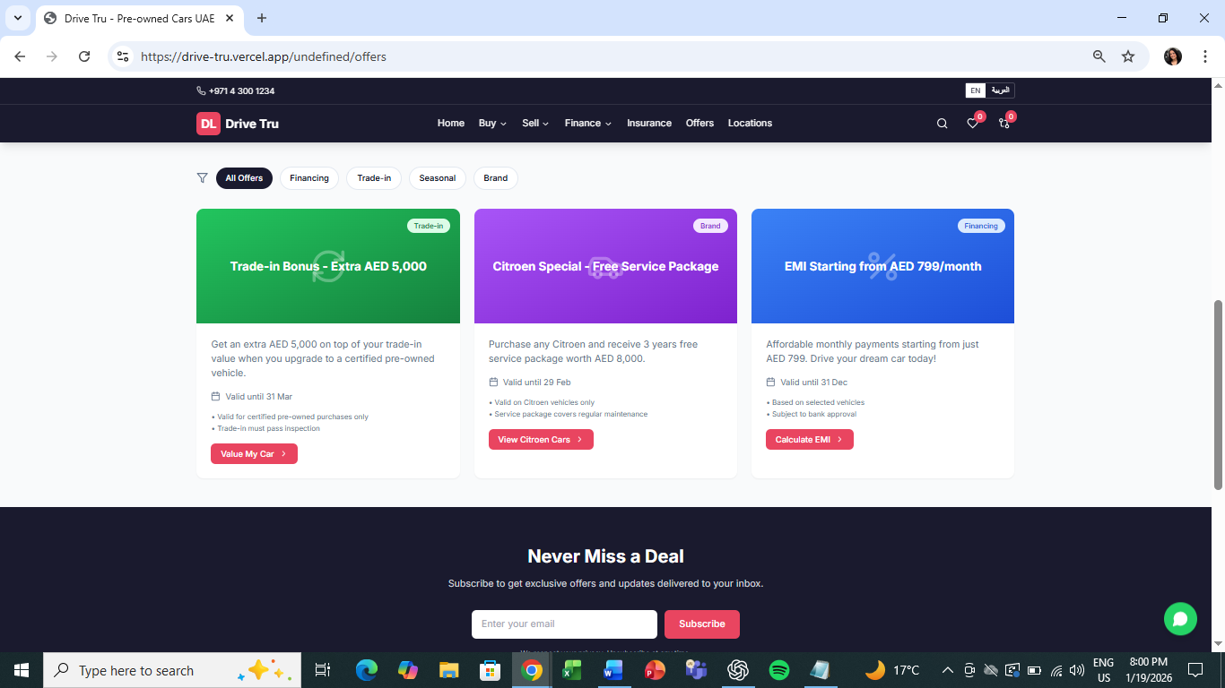

**Store locations with maps**

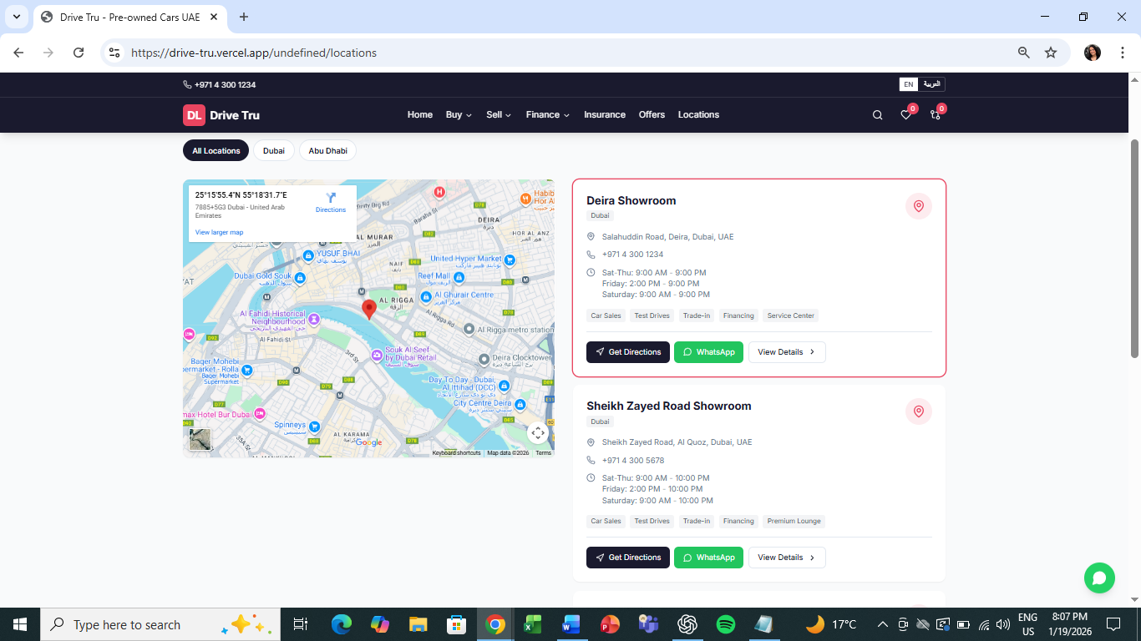

**Store locations with maps**

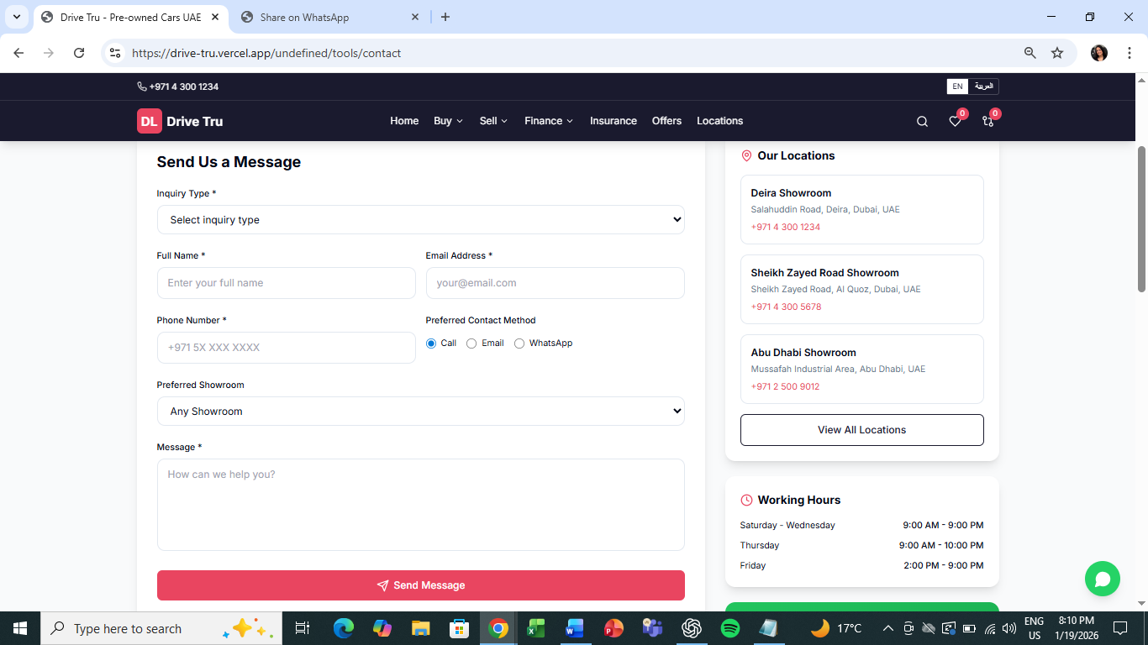

### 6.2 Dynamic Content

* Vehicle inventory (synced from KeyLoop + image API)
* Offers/promotions (CMS managed)
* News/Articles (optional, CMS managed)

## 7. Assumptions & Dependencies

### Assumptions

* KeyLoop DMS API is available and documented
* Dubizzle/YallaMotors provide publishing APIs
* AlgoDriven valuation API is accessible
* Vehicle images are available in KeyLoop or via Pixel Ride
* Arabic translations will be provided and reviewed by clients

### Dependencies

* Brand guidelines and assets from ARTC
* Showroom locations and operating hours
* Bank partner agreements for financing display
* Insurance partner agreements
* API credentials for all integrations
* SAP module names and use cases
* Exact use cases for all 3rd party integrations (keyloop, pixel ride, images API, SAP)

**Note: This document accompanies a working design prototype. All features marked as “Must” are demonstrated in the prototype with mock data and simulated integrations**